**Process Report**

“MediaBazaar”

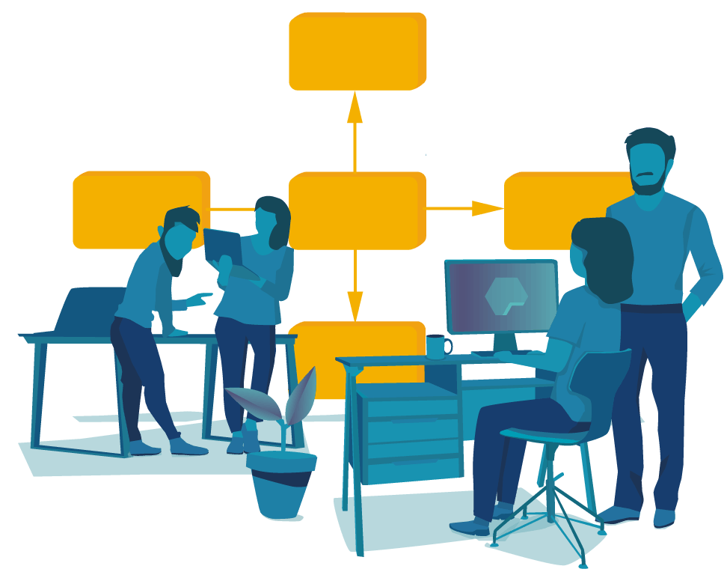

Student| Student number:

I B | x

Tudor Rusu | x

E P | x

V K | x

Tutor: Chung Kuah

FONTYS UNIVERSITY OF APPLIED SCIENCES

**HBO-ICT: English Stream**

March 2024

Table of Contents

Work division 2

Personal reflection 3

I B 3

Tudor Rusu 4

E P 5

V K 6

Reflection about Waterfall 7

# Work division

In the first 2 weeks the work was divided as evenly as it possibly could. The team worked together on every task, every deliverable, staying every day at school till the building was closing. Working on the project or other assignments together also served as a quality bonding time as we helped each other a lot. This way we all were able to stay on top on our group’s progress.

To provide a rough work distribution:

**I B:** preparing Minutes of each Meeting, making GUI sketches.

**V K:** making GUI and all icons of the design.

**E P:** most of the documentation, setting up the meetings, leading discussions and brainstorming sessions.

**Tudor Rusu:** most of the UML and DB.

However, every submission was proofread by the whole team (using a projector or an extra screen) to make sure we all could follow and provide input. The analysis and planning were made on the whiteboard where the team all brainstormed together.

Later in the process the team lost 1 member for almost 2 weeks due to health issues. This shifted the dynamics a bit as we had to cope with 3 members only. Once the member got better, we kept her up to date on our progress and all new tasks and decisions.

**I B:** preparing Minutes of each Meeting, updating the database to fit the data requirements of each function.

**V K:** updating the final look of the GUI design.

**E P:** remaining documentation, announcement panel, final presentation.

**Tudor Rusu:** most of the application code and connection to the database.

# Personal reflection

## I B

In our group everyone is cooperative, helpful and pleasant to work with. I find that very effective because we could all help each other and solve all the problems in a faster and more efficient way.   
 In the last few weeks I was absent due to illness and I felt like I missed a lot and did not help as much as I should. Regarding the project itself, I would say that it went pretty well. Personaly, I found organizing time a bit difficult. Besides the project, we also had two deadlines for two subjects in the same week and it was hard to equally distribute time to finish all assignments on time and that means that some subjetcts were “sacrificed“ in order to finish the rest. In order for that to not happen again, I would like to improve my organizational skills. The other thing that I would like to work on is my activity. I am usualy not active (talking) in meetings and would like to change that. I do write Minutes of the meeting, but I feel like my input by talking would also help my group and tutor when we are asked or simply have questions.

## Tudor Rusu

I would like to start by saying that for me, this is the best team I have working in so far during my studies in this university. I want to enforce my statement by saying that we all have put a lot of effort in this project by staying everyday over the normal hours in order to work on all the deliverables.

I really liked the way we collaborated and divided tasks and roles in order to simulate a real team and its dynamics. The problems started to arise when one of our teammates got sick, which made the job for us a bit harder, but in the end, everything worked out, proving furthermore that we have the right ingredients of a good team.

Finally, when we were about to start coding, the outbreak happened, and we were bound to stay home and made the collaboration very hard due to the fact that every individual has its own rhythm and routine. In my opinion everyone did their best, and I am really glad that we are all healthy and ready to finish what we have started.

## E P

I would like to start my reflection on the problems we experienced with the team during our project. The beginning of it was quite smooth and we were all involved 100% and working together on every little task. However, the challenges we faced appeared a bit later due to members absence. Although, I admit it was tough to maintain proper communication and fair work distribution in this time.

Moreover, since in the beginning it was difficult to foresee all the tiny details of the project we did not acquire enough information during the initial interview with the customer and were a bit confused on how to proceed with the implementation in the last weeks. Overall, grasping the scope of the project was a challenge on its own. We have struggled to anticipate the parts that we CAN implement during the “part I” and therefore we overpromised a bit. Thankfully, the tutor was trying to pull us back to the ground by pressuring us to be more realistic with our promises and focus only on the must-haves for now.

For the future, I believe we should be more “grounded”, deviate less from the base requirements and follow the plan/ schedule as much as possible, furthermore, shift our work distribution a bit to get out of our comfort zone and improve in different areas. Last but not least, personally for me to step down a little and encourage other members to be more proactive.

Overall, I felt that our team had a very positive atmosphere, where we all participated and welcomed each other’s ideas, feedback and overall input. The teammates are very supportive both physically (with tasks) and mentally (when you feel overwhelmed or incompetent). I find it very significant as it is always pleasant to work in such encouraging environment. Most important is that we managed to finish what we set out to as well as have some fun in the process.

## V K

The project is something that is meant to put people together and they should work with each other to provide in the end a working application. This application includes everything that the client asked for. Working in this team was and still is great.

To begin with this team is the best team that I have ever had in this past year. We managed to finish the project, even if there are some things that the tutor did not like, on time. The working ethic of the group for me was perfect. We had a lot of meetings between ourselves. We met after our class and stayed until the university closes.

The collaboration was one of the things I liked because we all worked together, and we divided the tasks corresponding on people’s strong sides and weak sides. The dynamic of the group was that of a real programing team. There are always problems that accrue even in big professional teams that cannot be avoided. One of our team members got sick, that lead to a little hiccup in the workflow, but we managed to get over that and finished the program that was asked for.

In conclusion working in this team is a pleasure. We work seriously and passionately. We help each other out and discus everything. The problems that accrue have always a solution and we try to find it as fast as possible.

# Reflection about Waterfall

Waterfall method was used in the approach of this project. This was a new concept to us, and we used it for the first time. After the part I was completed we reflected on how it went.

The method made us work hard to see the whole picture at an early stage, as we had to define a schedule for waterfall steps and predefine clear starting points and conclusion of each step (Analysis, Design, Implementation, Testing and Deployment). This guided us to improve our planning and organizing skills as everything was predefined. Each goal is related to waterfall steps; therefore, the outcome was clear, though not exactly how to implement it. The testing phase is made easier by the methodology. It is a singular activity, where we were able to solely focus on it following the provided test cases.

On the other hand, analysis and Implementation were the trickier steps. Since planning is done only at an early stage when we still lack grasp of the project scope and knowledge about certain implementations it caused us a lot of struggles later. It was very challenging to predict the duration of each activity as the scope is much bigger (we had to plan a lot in advance). When the scope is too big, we could not really go deep into detail and thus were lacking those once we arrived at an Implementation phase.

Overall, as data is being gathered only at an early stage (analysis, interview) we ran a high risk of taking longer to deliver and had higher chance of deviating from the initial promise.